ECEN 361 Project Status Report
  - Phreaks4Security
Kein Lika, James Green, Nicholas Bastian, Joel Brautigam

Project Scope
Highlight any changes to the project scope: strikethrough for removal, bold for new, normal for unchanged.
What It Is:
This project is a smart home security system built using embedded systems technology. It combines hardware sensors, a microcontroller, and a user interface to monitor and protect residential space. The system will be capable of detecting unauthorized entry, monitoring environmental conditions, and providing real-time feedback and control to the user.
What It Will Do:
- Monitor Entry Points:
Use magnetic reed switches to detect when doors or windows are opened.
- Detect Motion:
Use PIR (Passive Infrared) sensors to detect movement within the home.
- Trigger Alerts:
Activate alarms (buzzer, LED, or notifications) when suspicious activity is detected.
- User Interaction via UI:
Provide a graphical user interface (GUI) or mobile/web dashboard where users can:
  - Arm/disarm the system.
  - View real-time sensor data.
  - Receive alerts and logs.
  - Configure system settings.
- Optional Features:
  - Environmental monitoring (e.g., temperature, smoke, gas).
  - Remote access via Wi-Fi or cloud services.
  - Battery backup or low-power operation.
Why It Is Important:
- Real-World Relevance:
Home security is a critical concern, and this project simulates a practical application of embedded systems in everyday life.
- Skill Development:
Students will gain hands-on experience with:
  - Sensor integration.
  - Microcontroller programming.
  - Communication protocols (e.g., UART, I2C, Wi-Fi).
  - UI/UX design and development.
  - System debugging and testing.
- Interdisciplinary Learning:
Combines knowledge from electronics, software engineering, networking, and human-computer interaction.
- Scalability and Innovation:
The project can be expanded with features like facial recognition, voice control, or AI-based threat detection, encouraging creativity and deeper learning.

Schedule and Meeting Attendance
Update your set of tasks in Monday.com. Create new tasks as necessary. Export main table to Excel, Kanban board to PDF, and Gantt chart to PDF and turn in with this sheet.
Joel Brautigam – Was at the meeting in-person
Nicholas Bastian – Was at the meeting in-person
James Green – Was at the meeting via Zoom Call
Kein Lika – Briefly meet over phone and gave status reports via text

Derived Requirements
Update the requirements for your project. Highlight changes: strikethrough for removed requirements, bold for new requirements, normal font for unchanged.

General Requirements
Form Factor
- Small, contained units.
- Sensors are individual.
- Wired connections
Power
- Runs off 120v AC.
Hardware
- Currently we want the system to run on a Raspberry Pi. For sake of our software lead.
Interface
- Some sort of applet could be web based, but it runs locally on the pi.

Interface Requirements
Interface requirements detail the interfaces of the system and cover items such as communication standards, protocols, baud/bit rates, cloud connectivity, security, etc. Use these to help guide hardware selection and software design.
Communication Protocols
- UART (9600–115200 bps): For serial communication with sensors and actuators.
- I2C (100–400 kHz): For low-speed sensor interfacing.
- SPI (up to 10 MHz): For high-speed peripherals.
- Wi-Fi (802.11 b/g/n): For wireless connectivity to cloud and UI.
Cloud & Remote Access
- Protocols: MQTT (port 1883/8883) and HTTPS (port 443).
- Platform: AWS IoT, Firebase, or similar.
- Features: Real-time data, alerts, remote control via web/mobile dashboard.
Security
- Authentication: Login required for dashboard access.
Hardware Interfaces
- GPIO: For sensor and actuator connections.
- Power: 120V AC with optional battery backup.

Functional Requirements
Functional requirements detail the features and overall functionality of the system and cover items such as specific capabilities and behaviors required to fulfill the scope of the project.
Security Monitoring
- Entry Detection: Magnetic reed switches detect door/window openings.
- Motion Detection: PIR sensors monitor movement inside the home.
- Alert System: Triggers alarms (buzzer, LED, or notifications) upon suspicious activity.
User Interaction
- Dashboard Access: Users can arm/disarm the system, view sensor data, receive alerts, and configure settings via a local web or mobile dashboard.
Environmental Monitoring (Optional)
- Sensors: Monitor temperature, smoke, and gas levels.
- Alerts: Notify users of abnormal environmental conditions.
Remote Access
- Wi-Fi/Cloud Integration: Enables system control and monitoring from remote devices.
Power Management
- Primary Power: Operates on 120V AC.
- Backup: Optional battery support for power outages.
- Efficiency: Uses sleep modes and interrupts to conserve energy.
System Reliability
- Real-Time Response: Immediate reaction to sensor inputs.
- Data Logging: Stores event logs for review.
- Testing & Debugging: Includes tools like serial monitors and logic analyzers.

Hardware Block Diagram
Update your hardware block diagram showing the major hardware components, how they connect, how they are powered, etc. Use a professional tool such as LucidChart, draw.io, or Miro for this. Export a PDF and turn in with this sheet.
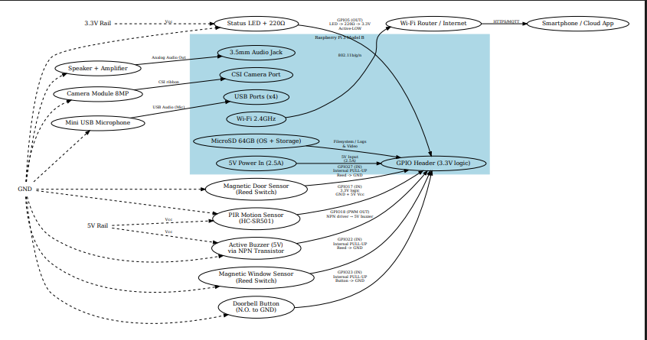

Software Block Diagram
Update your software block diagram showing the major software modules, how they connect, how they interface with hardware, etc. Use a professional tool such as LucidChart, draw.io, or Miro for this. Export a PDF and turn in with this sheet
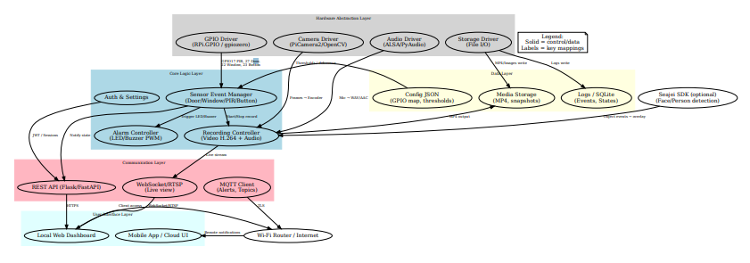.

Challenges and Victories
Report on any challenges, victories, and failures seen this week. What lessons were learned? How does it affect the scope and requirements of the project, if at all?

Challenges
- Finding time to do it all

Victories
- Managed to get all the parts we need for the project so far

Failures
- Personal ones

Lessons
We will need to meet more than once a week if we are to help on another more.

